Assignment 1

Assignment 1-A

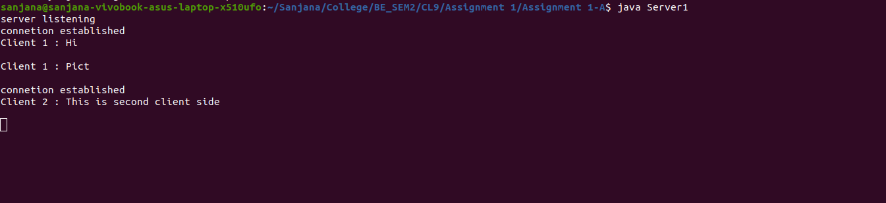
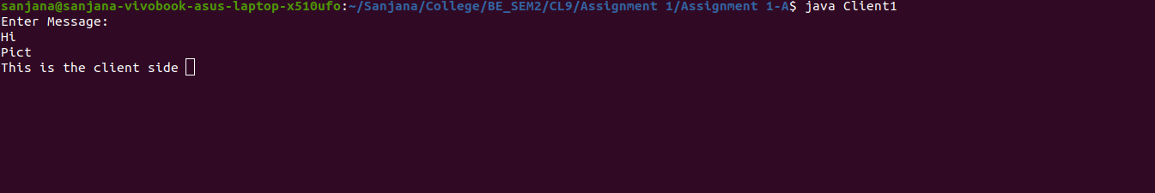
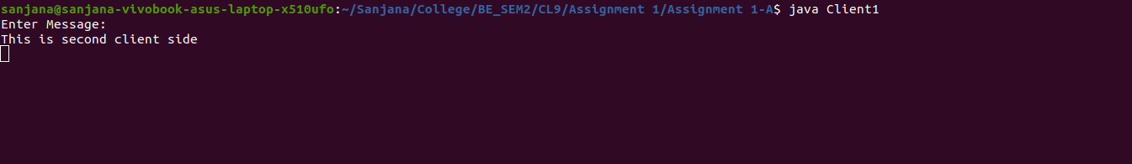

Client1.java

import java.util.*;
import java.net.*;
import java.io.*;

public class Client1 {

public static void main(String s[]) throws Exception {
Socket s1 = null;
String line = null;
DataInputStream br = null;
DataInputStream is = null;
PrintWriter os = null;
try {
s1 = new Socket("localhost", 4445);
br = new DataInputStream(System.in);
is = new DataInputStream(s1.getInputStream());
os = new PrintWriter(s1.getOutputStream());

} catch (IOException e) {
System.err.print("IO Exception");

}
String res = null;
try {
System.out.println("Enter Message: ");
line = br.readLine();
while (line.compareTo("QUIT") != 0) {
os.println(line);
os.flush();
res = is.readLine();
line = br.readLine();
}
is.close();
os.close();
br.close();
s1.close();
System.out.println("Close connection ");
} catch (IOException e) {
System.out.println("Socket read error");
}
}
}

Server1.java

import java.util.*;
import java.net.*;
import java.io.*;

public class Server1 {

public static void main(String s[]) throws Exception {
Socket sa = null;
ServerSocket ss2 = null;
System.out.println("server listening ");
try {
ss2 = new ServerSocket(4445);
} catch (IOException e) {
System.out.println("server error");
}
int i =1;
while (true) {
try {
sa = ss2.accept();
System.out.println("connetion established");

ServerThread st = new ServerThread(sa,"Client "+String.valueOf(i));
i++;
st.start();
} catch (Exception e) {
System.out.println("connetion error");
}
}
}
}

class ServerThread extends Thread {
String line = null;
DataInputStream is = null;
PrintWriter od = null;
Socket s1 = null;
String clientnum = "";
public ServerThread(Socket s, String clientnum) {
s1 = s;
this.clientnum= clientnum;
}

public void run() {
try {

is = new DataInputStream(s1.getInputStream());
od = new PrintWriter(s1.getOutputStream());
DataInputStream din = new DataInputStream(System.in);

line = is.readLine();
while (!line.equals("QUIT")) {
od.println(line);
od.flush();
System.out.println(clientnum+" : "+line+"\n");
line = is.readLine();

}
is.close();
od.close();
s1.close();

} catch (IOException ie) {
System.out.println("socket close error");
}
}
}
Assignment 1-B

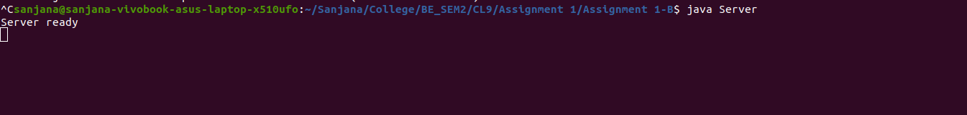
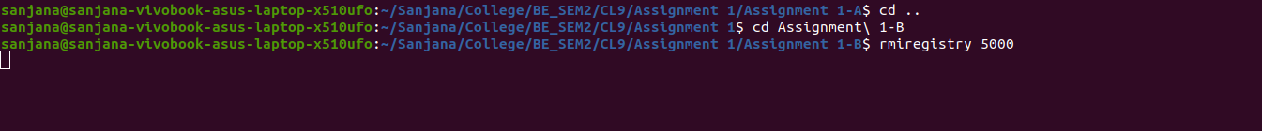
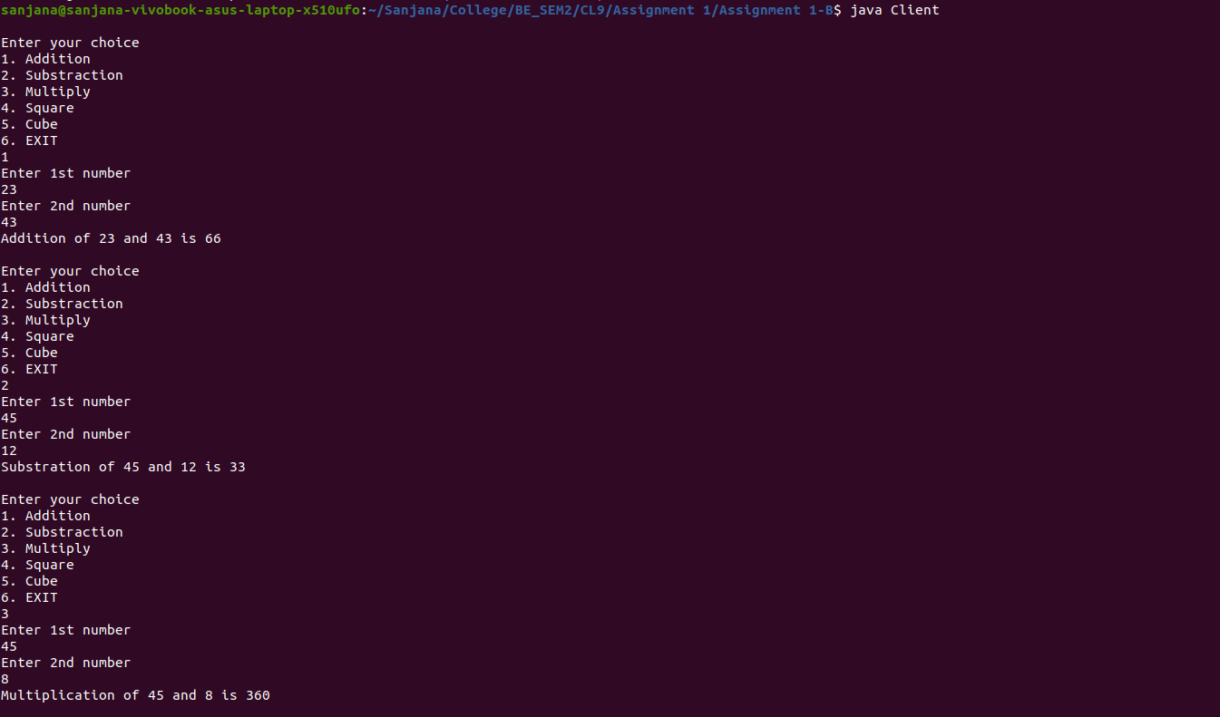

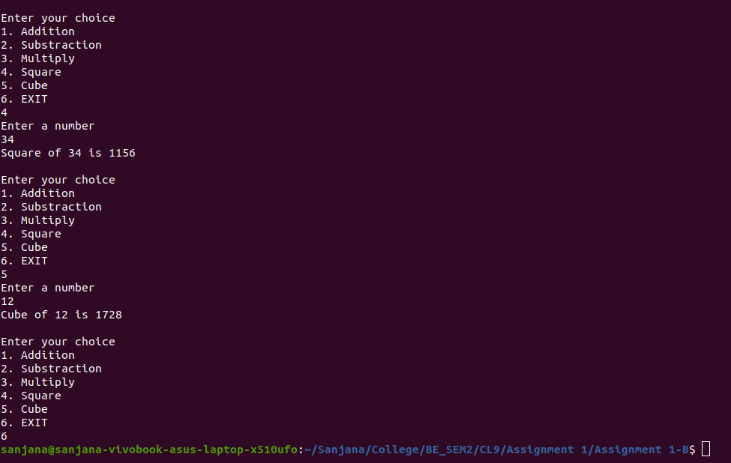
Calc.java

import java.rmi.*;

public interface Calc extends Remote{
public int add(int x,int y)throws RemoteException;
public int substract(int x,int y)throws RemoteException;
public int multiply1(int x,int y)throws RemoteException;
public int square(int x)throws RemoteException;
public int cube(int x)throws RemoteException;
}

CalcRemote.java

import java.rmi.*;
import java.rmi.server.*;
public class CalcRemote extends UnicastRemoteObject implements Calc{
CalcRemote()throws RemoteException{
super();
}
public int add(int x,int y){return x+y;}
public int substract(int x,int y){return x-y;}
public int multiply1(int x,int y){return x*y;}
public int square(int x){return x*x;}
public int cube(int x){return x*x*x;}
}

Client.java

import java.rmi.registry.*;
import java.rmi.*;
import java.rmi.server.*;
import java.util.*;
public class Client{
private Client()throws RemoteException {}
public static void main(String[] args) {
try{
Calc stub=(Calc)Naming.lookup("rmi://localhost:5000/calculate");
Scanner sc = new Scanner(System.in);

int a,b,choice;
while(true){
System.out.println("\nEnter your choice");
System.out.println("1. Addition");
System.out.println("2. Substraction");
System.out.println("3. Multiply");
System.out.println("4. Square");
System.out.println("5. Cube");
System.out.println("6. EXIT");
choice= sc.nextInt();
switch(choice)
{
case 1: System.out.println("Enter 1st number");
a = sc.nextInt();
System.out.println("Enter 2nd number");
b = sc.nextInt();
System.out.println("Addition of "+a+" and "+b+" is "+stub.add(a,b));
break;
case 2: System.out.println("Enter 1st number");
a = sc.nextInt();
System.out.println("Enter 2nd number");
b = sc.nextInt();
System.out.println("Substration of "+a+" and "+b+" is "+stub.substract(a,b));
break;
case 3: System.out.println("Enter 1st number");
a = sc.nextInt();
System.out.println("Enter 2nd number");
b = sc.nextInt();
System.out.println("Multiplication of "+a+" and "+b+" is "+stub.multiply1(a,b));
break;
case 4: System.out.println("Enter a number");
a = sc.nextInt();
System.out.println("Square of "+a+" is "+stub.square(a));
break;
case 5: System.out.println("Enter a number");
a = sc.nextInt();
System.out.println("Cube of "+a+" is "+stub.cube(a));
break;
case 6: System.exit(0);

}
}

}
catch(Exception e){
System.out.println(e);
}
}
}

Server.java

import java.rmi.*;
import java.rmi.server.*;
import java.rmi.registry.*;
public class Server extends CalcRemote {

public Server() throws RemoteException {}

public static void main(String[] args) {
try{
Calc stub=new CalcRemote();
Naming.rebind("rmi://localhost:5000/calculate",stub);
System.err.println("Server ready");
}
catch(Exception e){
System.out.println(e);
}
}
}

